Mass Production High Mechanical Properties Electrical and Electronic Material: Graphene-copper Nanocomposites

Fig. S1
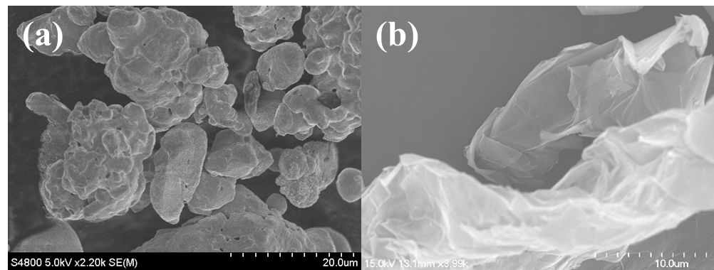
Fig. S1 SEM images of the commercial (a) Cu powder and (b) graphene sheets

Fig. S2
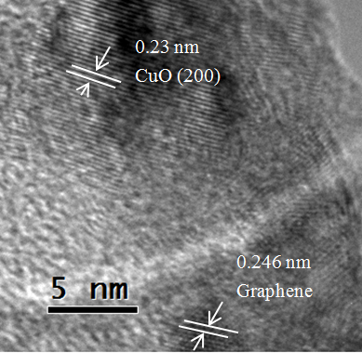
Fig. S2 HRTEM images of 5 wt.% Gr-Cu composite which shows graphene and CuO
Fig S3
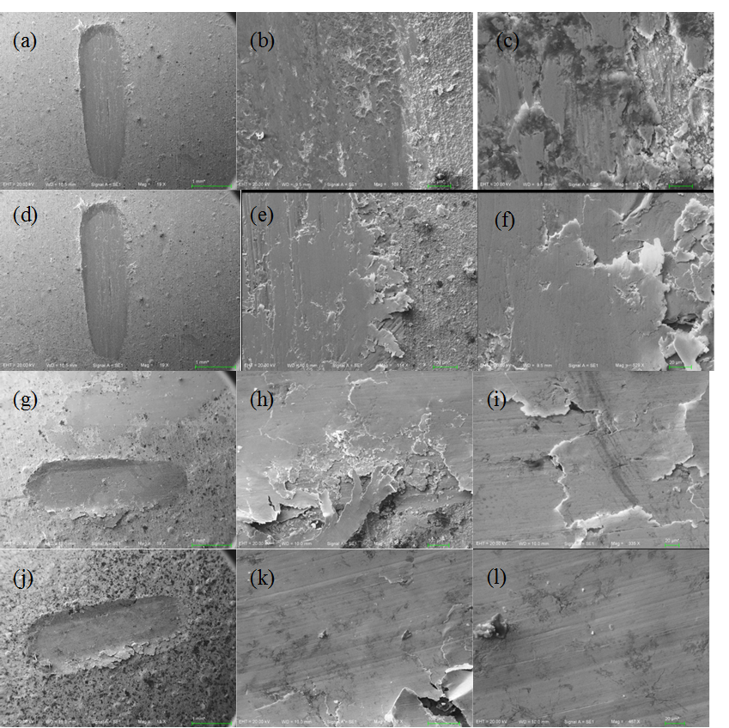
Fig. S3 SEM morphologies of the wear tracks of vacuum sintered Gr-Cu composites with different graphene content; (a)-(c) Cu, (d)-(f) 1 wt. %, (g)-(i) 2.5% wt. % and (j)-(l) 5% wt. % Gr-Cu composites at a constant sliding speed of 25 mm/s for 5 min.

