Supplementary Information

Conversion of carbon nanotube into curved graphene with improved capacitance

LI Xiao-yan¹, WANG Qiang^{2,} *, WANG Huan-wen³
(1. School of Chemistry and Chemical Engineering, Shanxi University, Taiyuan 030006, China；
2. State Key Laboratory of Coal Conversion, CAS Key Laboratory of Carbon Materials, Institute of Coal Chemistry, Chinese Academy of Sciences, Taiyuan 030001, China;
3. Faculty of Material Science and Chemistry, China University of Geosciences, Wuhan 430074, China )
Corresponding author: WANG Qiang, associate professor. E-mail: wqiang@sxicc.ac.cn

Materials characterization
The morphology and microstructure were characterized by XRD (Bruker D8 Advance with Cu-Kα radiation), SEM (Hitachi SU8010 at 10.0 kV) and TEM (Titan G260-300).
Preparation of electrodes
The samples, super P and PTFE binder were mixed in a weight ratio of 80:10:10, using N-methyl-2-pyrrolidone as the solvent to form a paste, which was coated onto nickel foam, and the mass of active material was 2.0 mg cm^{‒1}.
Electrochemical characterization
A three-electrode experimental cell with the working electrode, the platinum foil counter electrode, and the SCE reference electrode was used to measure electrochemical properties in 1 M Na₂SO₄ aqueous electrolyte. Cyclic voltammetry (CV) was carried out on a CHI660B electrochemical working station. The specific capacitance of the electrode can be calculated according to C= (∫IdV)/(ʋmV), where C is the specific capacitance (F g^{‒1}), I is the response current density (A cm^{‒2}), V is the potential (V), ʋ is the potential scan rate (mV s^{‒1}), and m is the mass of the electroactive materials in the electrodes (g).

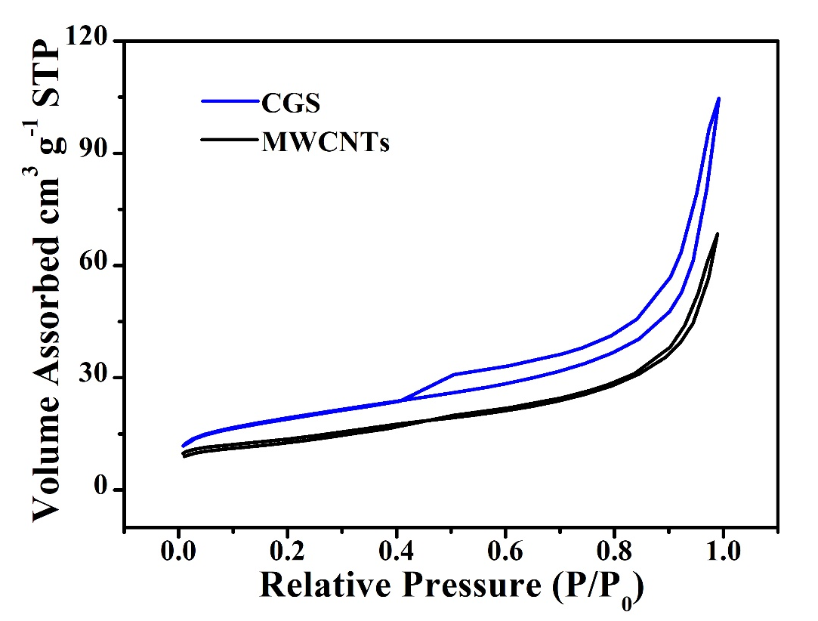
Fig. S1. Nitrogen adsorption and desorption isotherms for (a) CGS and (b) MWCNTs.

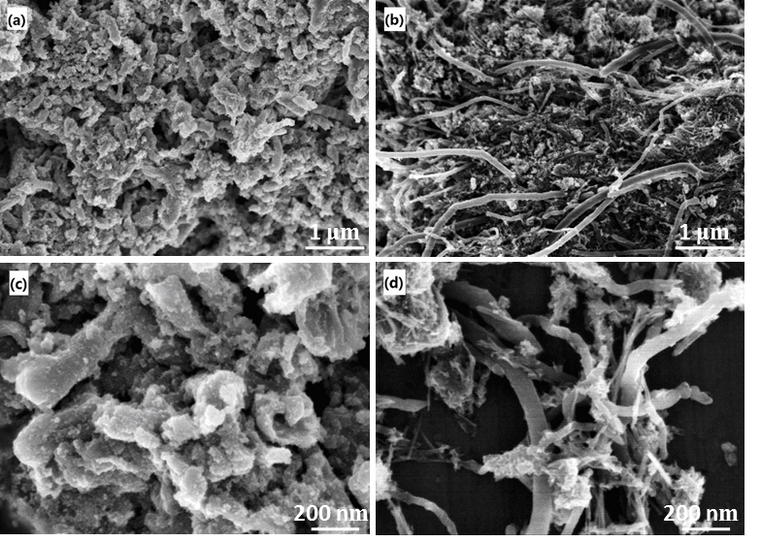
Fig. S2. FESEM images of (a, c) the CGS-MnO₂ composite and (b, d) MWCNTs-MnO₂ composite.

Fig. S3. TG/DTG curves of the CGS-MnO₂ composite.

Fig. S4. N₂ adsorption–desorption isotherms of CGS-MnO₂.

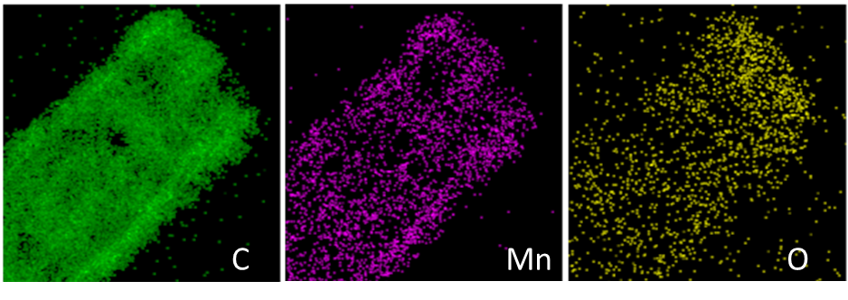
Fig. S5. EDS mapping results of CGS-MnO₂.

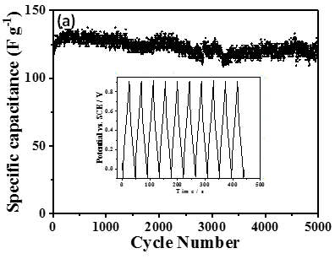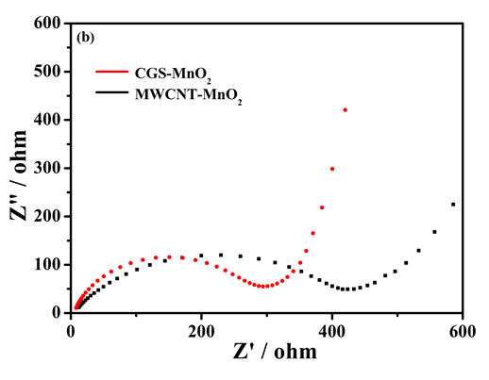
Fig. S6. (a) Cycling stability of CGS-MnO₂ obtained by galvanostatic charge/discharge. (b) EIS data of CGS-MnO₂ and MWCNT-MnO₂.
1 μm
200 nm
1 μm
200 nm

